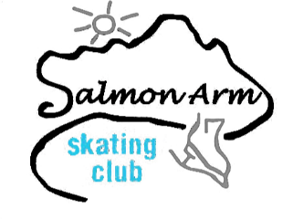
Salmon Arm Skating Club Registration Form
Sr. & Intermediate Starskate (Spring 2019)

PO Box 1488, Salmon Arm, BC V1E 4P6
salmonarmskatingclub@gmail.com
www.saskatingclub.com

Contact: Lori-Ann Williams 250-803-2583 or Crystal de Boer 250-575-8411
NAME OF SKATER: | FEMALE: ____ MALE: ____
ADDRESS/CITY: | POSTAL CODE:
EMAIL: | DATE OF BIRTH:
NAMES OF PARENTS/GUARDIANS: | CONTACT PHONE NUMBER(S):
HEALTH CONCERNS: | CARE CARD #
Previously Registered with Skate Canada: YES or NO | Skate Canada Number, if known:

PROGRAM | DATE |  | TIME |  | COST
INTERMEDIATE | Mar. 18, 20, 21, 25, 27, 28 Apr. 1, 3,  Apr. 10, 11 |  | 5:30 - 6:45 PM  4 – 5 PM |  | $ 180.00 _______
SR. STARSKATE | Mar. 18, 20, 21, 25, 27, 28, Apr. 1, 3,  Apr. 10, 11 |  | 6:00 - 7:30 PM  5 – 6:30 PM |  | $ 210.00 _______
DROP IN FEE: | INTERMEDIATE/Session $22 SR. STARSKATE/Session $24
INSURANCE & SKATE CANADA FEES | Paid once per skating year. (Sept to Aug) |  |  | TOTAL DUE |  | $ 38.00 _______  $ ___________

Family Discount of 10% off each registration starting with the third registered skaters. (NO discount on Insurance and Skate Canada Fee) Full Payment due at time of registration. Payment plan available upon request only.

Preferred Way of Contact: TEXT: ____ EMAIL: ____ PAPER: ____
PLEASE READ AND SIGN BELOW:
I will not hold the SASC, their officers or employees responsible for injuries or property damages.
I will abide by the rules of Skate Canada and the SASC.
Refunds are granted on a case by case basis as determined by SASC. Medical documentation is required. Skate Canada Fees are non-refundable.

SIGNATURE | OFFICE USE ONLY
AMOUNT PAID: SASC Initials:
CASH $ CHEQUE $ #

