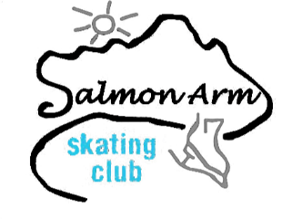
Salmon Arm Skating Club Registration Form
Canskate (Winter 2019)
PO Box 1488, Salmon Arm, BC V1E 4P6
salmonarmskatingclub@gmail.com
www.saskatingclub.com
Contact: Lori-Ann Williams 250-803-2583 or Crystal de Boer 250-575-8411
NAME OF SKATER: | FEMALE: ____ MALE: ____
ADDRESS/CITY: | POSTAL CODE:
EMAIL: | DATE OF BIRTH:
NAMES OF PARENTS/GUARDIANS: | CONTACT PHONE NUMBER(S):
HEALTH CONCERNS: | CARE CARD #
Previously Registered with Skate Canada: YES or NO | Skate Canada Number, if known:
PROGRAM | DAY | DATE | TIME | COST
PRE-CANSKATE | Monday | Jan 7th – Mar 11th | 4:15 - 4:45 PM | $ 120.00 _______
 | Thursday | Jan 10th – Mar 7th | 4:15 - 4:45 PM | $ 120.00 _______
CANSKATE | Monday | Jan 7th – Mar 11th | 4:30 – 5:15 PM | $ 150.00 _______
 | Thursday | Jan 10th – Mar 7th | 4:30 - 5:15 PM | $ 150.00 _______
INSURANCE & SKATE CANADA FEES | Paid once per skating year. (Sept to Aug) |  | TOTAL DUE | $ 38.00 _______  $ ___________

** NO SKATING FEBRUARY 18th **

Family Discount of 10% off each registration starting with the third registered skaters. (NO discount on Insurance and Skate Canada Fee) Full Payment due at time of registration. Payment plan available upon request only. Your Skater also has the option of skating in Sicamous, please find registration form on the website. www.saskatingclub.com
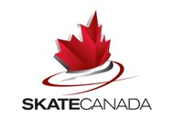
Preferred way of contact: TEXT: ____ EMAIL: ____ PAPER: ____

PLEASE READ AND SIGN BELOW:
I will not hold the SASC, their officers or employees responsible for injuries or property damages.
I will abide by the rules of Skate Canada and the SASC.
Refunds are granted on a case by case basis as determined by SASC. Medical documentation is required. Skate Canada Fees are non-refundable.

SIGNATURE | OFFICE USE ONLY
AMOUNT PAID: SASC Initials:
CASH $ CHEQUE $ #

